Phil Brown Assignment 8.2

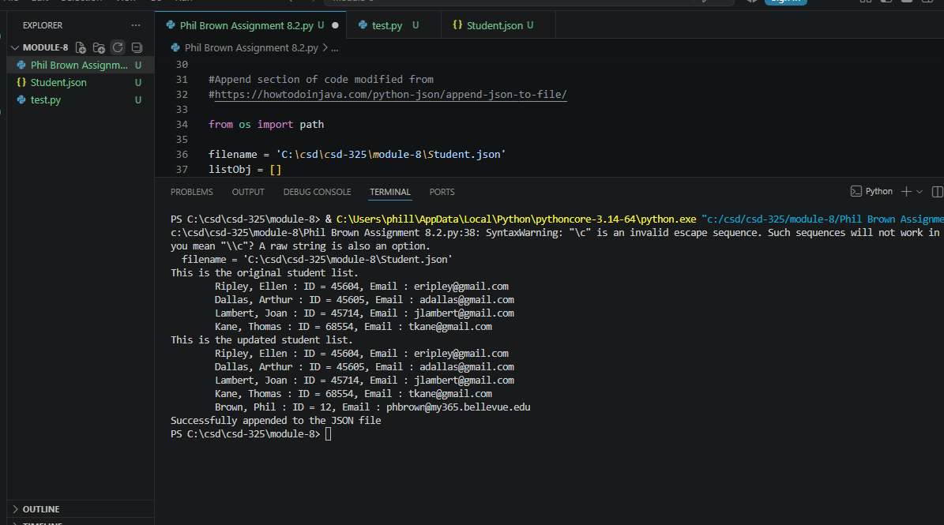

Once the program runs, you should also see a notification that the student.json file has changed, with a choice to save or not. Take a screen shot of the notification and paste into your Word document. Should look similar to the image below:
PTB Note: I did not get a notification asking me to save. I googled it and it seems like I would have to specifically code that using something called “Tkinter”. I did not think that was the point of the assignment so I did not do that. Hopefully I am not wrong on that.
Updated json file:
[
{
"F_Name": "Ellen",
"L_Name": "Ripley",
"Student_ID": 45604,
"Email": "eripley@gmail.com"
},
{
"F_Name": "Arthur",
"L_Name": "Dallas",
"Student_ID": 45605,
"Email": "adallas@gmail.com"
},
{
"F_Name": "Joan",
"L_Name": "Lambert",
"Student_ID": 45714,
"Email": "jlambert@gmail.com"
},
{
"F_Name": "Thomas",
"L_Name": "Kane",
"Student_ID": 68554,
"Email": "tkane@gmail.com"
},
{
"F_Name": "Phil",
"L_Name": "Brown",
"Student_ID": 12,
"Email": "phbrown@my365.bellevue.edu"
}
]

